Affiliated to Pokhara University
POKHARA ENGINEERING COLLEGE
Phirke, Pokhara-8
In partial fulfillment of the requirements for the Bachelor's Degree in Computer Engineering under Pokhara University.

A
Project Report on
CertifyED

Submitted by:
Bipin Pokhrel (22070448)
Milan Karki (22070453)
Sandesh Aryal (22070462)

Supervisor:
Asst. Prof. Er. Sabin Thapa

Submitted to:
Research Management Cell
Pokhara Engineering College
2026

Acknowledgement
The successful completion of this project would not have been possible without the guidance, encouragement, and support of many individuals. We would like to express our sincere gratitude to our project supervisor, Asst. Prof. Er. Sabin Thapa, for his valuable guidance, constructive suggestions, continuous encouragement, and insightful feedback throughout the planning, development, and completion of this project.
We are also grateful to Er. Krishna Ghimire, Coordinator of the Research Management Cell, Er. Suraj Basant Tulachan, Head of the Department of Computer Engineering, and all the lecturers and staff of Pokhara Engineering College for providing us with the necessary resources, facilities, and academic environment that greatly contributed to the successful completion of this project.
We would also like to thank everyone who directly or indirectly supported us during the development of this project. Their encouragement and cooperation helped us overcome various challenges encountered throughout the project.
Finally, we express our heartfelt appreciation to our parents, families, and friends for their constant motivation, patience, and unwavering support throughout this journey.

Abstract
CertifyED is a blockchain-backed digital certificate management and verification platform developed for educational institutions to securely issue, manage, and verify academic credentials. The system was developed using the Waterfall Software Development Methodology, following a structured approach consisting of system analysis, system design, system modeling, implementation, and testing to ensure the systematic development of the proposed solution.
The platform provides a centralized environment that enables institutions to generate certificates individually or in bulk through Excel file uploads, automatically deliver certificates via email with PDF attachments and unique verification codes, and maintain secure digital records. Blockchain technology is incorporated to ensure certificate integrity and prevent tampering by storing cryptographic certificate records on the Ethereum blockchain. Users can verify certificates through a publicly accessible verification portal using either a unique verification code or by uploading the certificate PDF.
Additional features include institution profile management, custom certificate branding, certificate search by recipient email, external document signing and verification, certificate revocation and unrevocation, detailed activity logging, and secure user authentication. The system was implemented using React with Vite for the frontend, Node.js and Express.js for the backend, MongoDB for database management, Ethereum smart contracts, and IPFS for decentralized certificate storage.
The completed platform provides a secure, scalable, and user-friendly solution that reduces manual administrative effort, minimizes certificate forgery, and simplifies the issuance and verification of academic credentials for educational institutions, students, and third-party organizations.
Keywords: academic credentials, blockchain, certificate verification, digital certificate management, Ethereum, IPFS, MongoDB, Node.js, smart contracts, Waterfall methodology.
Table of Contents
Acknowledgement i
Abstract ii
List of Figures .iv
List of Tables v
Abbreviations vi
Chapter 1: Introduction 1
1.1 Background 1
1.2 Statement of Problem 1
1.3 Objective 2
1.4 Scope of Project 2
1.5 Limitations 3
Chapter 2: Literature Review 4
Chapter 3: Methodology 6
3.1 System Analysis 6
3.2 System Design 10
3.3 System Modeling 11
3.4 Coding 19
3.5 Testing 20
Chapter 4: Project Schedule 22
Chapter 5: Conclusion 23
References 24
Annexes 26

List of Figures
Figure 3.1: System Architecture of CertifyED 11
Figure 3.2: Flowchart 12
Figure 3.3: Use Case Diagram 13
Figure 3.4: Level-0 DFD 14
Figure 3.5: Level-1 DFD 15
Figure 3.6: Activity Diagram 16
Figure 3.7: ER Diagram 17
Figure 3.8: Class Diagram 18

List of Tables
Table 2.1: Comparison of CertifyED with Existing Platforms 5
Table 3.1: RMMM Table 8
Table 3.2: Test Cases and Results 21
Table 4.1: Project Schedule 22

Abbreviations
API: Application Programming Interface
CSS: Cascading Style Sheets
DFD: Data Flow Diagram
ER: Entity Relationship
HTML: HyperText Markup Language
HTTP: HyperText Transfer Protocol
IPFS: InterPlanetary File System
JWT: JSON Web Token
JSX: JavaScript XML
ODM: Object Data Modeling
PDF: Portable Document Format
REST: Representational State Transfer
RMMM: Risk Mitigation, Monitoring, and Management
SaaS: Software as a Service
SMTP: Simple Mail Transfer Protocol
SSD: Solid State Drive
UI: User Interface
UML: Unified Modeling Language
URL: Uniform Resource Locator
UX: User Experience
vCPU: Virtual Central Processing Unit
VS Code: Visual Studio Code
XLSX: Microsoft Excel Open XML Spreadsheet

Chapter 1: Introduction

1.1 Background
The growing adoption of digital technologies in education has increased the need for secure and efficient certificate management. Traditional paper-based certificates are prone to forgery, loss, and slow verification. To address these issues, CertifyED was developed as a blockchain-backed digital certificate management and verification platform. Built using React, Node.js, MongoDB, Ethereum, and IPFS, the system enables secure certificate generation, management, automated email delivery, and tamper-resistant verification.

1.2 Statement of Problem
Educational institutions continue to face several challenges in managing academic certificates efficiently and securely. Conventional certificate management systems often rely on manual and paper-based documentation, making them vulnerable to forgery, loss, and administrative inefficiencies. The major problems identified are as follows:
- Educational institutions lack a centralized platform for issuing, managing, and maintaining digital academic certificates.
- Paper-based and manually issued certificates can be forged or altered, making authenticity difficult to guarantee.
- Existing verification methods often require direct communication with the issuing institution, resulting in delays and inconvenience.
- Managing large volumes of certificates manually increases administrative workload and the likelihood of human error.
- Many existing solutions do not provide integrated features such as bulk certificate generation, automated email delivery, certificate revocation, external document verification, and comprehensive activity auditing within a single platform.

1.3 Objective
The objectives of this project are:
- To develop a secure blockchain-backed digital certificate management and verification platform that enables educational institutions to generate, manage, and verify academic certificates efficiently.
- To provide a reliable, user-friendly, and tamper-resistant system with features such as certificate generation, automated email delivery, public verification, external document verification, activity logging, and certificate lifecycle management.

1.4 Scope of Project
The scope of the project includes the following:
- Enables educational institutions to generate certificates individually or in bulk using Excel file uploads.
- Automatically generates PDF certificates and delivers them to recipients via email.
- Provides public certificate verification using a verification code, PDF upload, or recipient email without requiring user login.
- Supports signing and verification of external PDF documents.
- Maintains tamper-resistant certificate records using Ethereum blockchain and IPFS.
- Allows institutions to manage their profile, institution name, and custom logo used in certificate generation.
- Maintains detailed activity logs and records of certificate-related operations.
- Provides a centralized dashboard to manage and categorize all generated and externally verified certificates.
- Implements secure user authentication with registration, email verification, login, and password reset functionality.
- Supports certificate download and efficient digital certificate lifecycle management through a web-based platform.

1.5 Limitations
The project has the following limitations:
- The system requires a stable internet connection for certificate generation, blockchain synchronization, email delivery, and public verification.
- Email delivery depends on third-party SMTP services, which may occasionally experience delays or spam filtering.
- Bulk certificate generation requires correctly formatted Excel files; incorrect formatting may result in processing errors.
- Blockchain transaction confirmation time may vary depending on network conditions and blockchain performance.
- The current implementation is designed primarily for educational institutions and may require customization for use in other sectors.
- The security and availability of the platform depend on the reliability of the hosting infrastructure and blockchain services.

Chapter 2: Literature Review
The rapid digital transformation of educational institutions has changed the way academic credentials are issued, stored, and verified. Traditional paper-based certificates are vulnerable to forgery, physical damage, and lengthy verification procedures. As a result, educational institutions are increasingly adopting digital credential management systems that provide secure issuance, storage, and verification of certificates. However, many existing solutions rely on centralized cloud infrastructure, limiting institutional control and transparency in credential management (Certifier, 2025).
Several modern digital credential platforms have been developed to address these challenges. Certopus (2022) enables organizations to generate certificates in bulk, automate email delivery, and verify digital credentials while integrating with learning management systems. Although it offers secure verification and workflow automation, it mainly relies on centralized cloud storage and lacks institution-controlled blockchain-based certificate management (Certopus, 2022).
CertifyMe provides W3C Verifiable Credentials, Open Badges support, blockchain-anchored verification, analytics, API integration, and branded credential management. While it offers secure and tamper-evident credentials, it primarily targets enterprise digital credentialing and provides limited support for institution-managed document signing and external PDF verification.
Similarly, Sertifier supports automated certificate generation, digital badges, credential verification, analytics, and LMS integration for educational institutions and training providers. However, it focuses mainly on credential issuance and sharing rather than comprehensive academic certificate lifecycle management, recipient email-based certificate search, and institution-controlled certificate storage.
The review of these systems shows that most platforms provide only selected features instead of a complete certificate lifecycle management solution. Common limitations include the absence of integrated external PDF signing and verification, recipient email-based certificate search, detailed activity logging, institution-controlled storage, and centralized management of both generated and externally verified certificates.
To overcome these limitations, CertifyED was developed as a blockchain-backed certificate management platform that combines certificate generation, blockchain verification, automated email delivery, public verification, activity logging, institution branding, and external document signing within a single web application.
Table 2.1: Comparison of CertifyED with Existing Platforms
S.N. | Feature | CertifyED | Certopus | CertifyMe | Sertifier
1. | Bulk Certificate Generation | Excel Upload | Excel/CSV | Bulk Upload | Bulk Upload
2. | Automated Email Delivery | PDF + Code | Yes | Yes | Yes
3. | Public Certificate Verification | Code & PDF | Link | Link | Link
4. | Blockchain Verification | Yes | No | Anchored | Limited
5. | External PDF Signing & Verification | Yes | No | No | No
6. | Recipient Email Search | Yes | No | No | No
7. | Institution Branding | Yes | Yes | Yes | Yes
8. | Activity Logging | Yes | Limited | Yes | Limited
9. | Institution controlled Database | MongoDB + IPFS | No | No | No
10. | Certificate Lifecycle Management | Yes | Partial | Partial | Partial

Chapter 3: Methodology
This chapter describes the methodology used to develop the CertifyED platform. The Waterfall Software Development Methodology was adopted, following a structured and sequential approach from planning to implementation (Royce, 1970). The chapter covers system analysis, system design, system modeling, and coding, which guided the successful development of the proposed system.

3.1 System Analysis
System analysis identifies the requirements and feasibility of the proposed system. For CertifyED, it focused on developing a secure blockchain-backed digital certificate management platform.
Requirement Analysis:
Requirement analysis identifies the software and hardware resources necessary for the development and deployment of the CertifyED platform.
Software Requirements:
- Visual Studio Code: Used as the primary source code editor for frontend and backend development.
- Node.js and npm: Provides the JavaScript runtime environment and package manager for installing project dependencies.
- React with Vite: Used to develop the responsive frontend user interface with fast development and build performance.
- Express.js: Backend framework used to build RESTful APIs and handle server-side logic.
- MongoDB: NoSQL database used to store user accounts, certificate information, activity logs, and application data.
- Docker Desktop: Used to run and manage containerized services, including the local blockchain environment.
- Ganache: Personal Ethereum blockchain used for developing, deploying, and testing smart contracts.
- Pinata (IPFS): Used to upload and manage certificate files on the InterPlanetary File System (IPFS) for decentralized storage.
- Git and GitHub: Used for version control, source code management, and project collaboration throughout development.
- Google Chrome or Microsoft Edge: Used for testing and interacting with the web application.
- Windows 10/11 or Linux: Operating system used for application development and deployment.
Hardware Requirements:
- Processor: Dual-core 2.0 GHz or higher
- RAM: Minimum 8 GB
- Storage: At least 20 GB SSD
- Frontend Server: 2 vCPUs, 2 GB RAM, 20 GB SSD
- Backend Server: 2 vCPUs, 4 GB RAM, 50 GB SSD
- Database: MongoDB Atlas or Self-hosted MongoDB
- Internet Connection: Stable internet connection
Feasibility Analysis:
The feasibility analysis confirmed that the proposed system is practical from technical, economic, schedule, and legal perspectives.
- Technical Feasibility: The system utilizes reliable technologies including React, Node.js, Express.js, MongoDB, Ethereum, IPFS, and Docker, all of which are widely adopted and well-supported.
- Economic Feasibility: Most development tools are open source, minimizing software costs. The primary operational expenses include cloud hosting, domain registration, and email services, making the platform affordable for educational institutions.
- Schedule Feasibility: The project was completed within the planned development schedule, with all core modules successfully implemented and tested.
- Legal Feasibility: The application uses open-source technologies and securely manages user and certificate data without violating software licensing or data privacy practices.
Risk Assessment:
Risk assessment is the process of identifying potential risks that may affect the security, reliability, and performance of the CertifyED platform. During the design and implementation of the system, possible risks were analyzed and appropriate mitigation strategies were incorporated to minimize their impact. This helps ensure secure certificate management, reliable verification, and continuous system availability.
The major risks identified in the system include:
- Invalid or incorrectly formatted Excel files during bulk certificate generation.
- Failure or delay in email delivery due to SMTP service limitations.
- Unauthorized access through compromised user credentials.
- Attempts to modify or forge issued certificate PDFs.
- Temporary unavailability of blockchain or IPFS services.
- Data loss caused by database or server failures.
- Network interruptions affecting certificate generation and verification.
- Human errors during certificate data entry or management.
- Failure to record user activities in the activity log.
Table 3.1: RMMM Table
S.N. | Activity | Associated Risks | Severity, Probability & Risk Score | Method(s) to manage risk
1. | Certificate Generation | Incorrect certificate information entered by the institution. | High  Medium  8 | Validate all required fields and allow preview before generating certificates.
2. | Bulk Certificate Generation | Malformed Excel files could cause partial or failed generation | High  Medium  8 | Validate Excel format and required columns before processing; return per-row error feedback.

S.N. | Activity | Associated Risks | Severity, Probability & Risk Score | Method(s) to manage risk
3. | Email Delivery Failure | Emails may not reach recipients due to spam filters or SMTP limits | Critical  Medium  9 | Implement retry logic, delivery status tracking, and fallback SMTP providers.
4. | User Authentication | Unauthorized access through compromised credentials. | Critical  Low  9 | Use JWT authentication, password hashing, email verification, and secure password reset.
5. | Certificate Forgery | Users may attempt to present tampered PDF certificates | Medium  Low  7 | Store cryptographic hash on blockchain; PDF verification re-hashes the file and compares against the on-chain record.
6. | Blockchain Operations | Blockchain transaction failure or delayed confirmation. | Medium  Low  6 | Validate transaction status and notify users of successful or failed blockchain operations.
7. | IPFS Storage | Certificate file unavailable due to IPFS service interruption. | Medium  Low  6 | Store IPFS hash securely and implement retry mechanisms with proper error handling.
8. | Database Management | Loss or corruption of certificate and user data. | Critical  Low  9 | Perform regular database backups and validate all database operations before committing changes.
9. | Activity Logging | Failure to record important user activities. | Medium  Low  5 | Automatically log all critical system activities and monitor log integrity.

Cost-Benefit Analysis:
The development of CertifyED required investment in software development, deployment, and maintenance resources while providing substantial long-term benefits.
Project Costs:
- Cloud hosting and domain registration
- Internet and server infrastructure
- Development and testing resources
- Documentation and printing expenses
- Deployment and maintenance costs
Project Benefits:
- Reduces manual certificate issuance and management.
- Prevents certificate forgery through blockchain-backed verification.
- Enables automated email delivery and bulk certificate generation.
- Provides public certificate verification without user login.
- Maintains comprehensive activity logs for auditing and transparency.
- Improves administrative efficiency while reducing long-term operational costs.

3.2 System Design
The CertifyED platform follows a client-server architecture that separates the user interface, application logic, data storage, and blockchain services into independent components (Oracle, n.d.). Users interact with the system through a web browser, where the React-based frontend communicates with the backend using RESTful APIs (Fielding, 2000). The backend, developed with Node.js and Express.js, processes user requests, performs authentication, generates certificates, verifies certificate authenticity, manages activity logs, and coordinates communication with external services. MongoDB stores application data, Ethereum blockchain (Ganache) maintains immutable certificate hashes for verification, and IPFS through Pinata stores certificate PDF files in decentralized storage (Protocol Labs, n.d.).
An integrated email service automatically delivers generated certificates to recipients. This architecture provides a secure, scalable, and efficient solution for digital certificate management while ensuring data integrity and simplifying certificate verification.
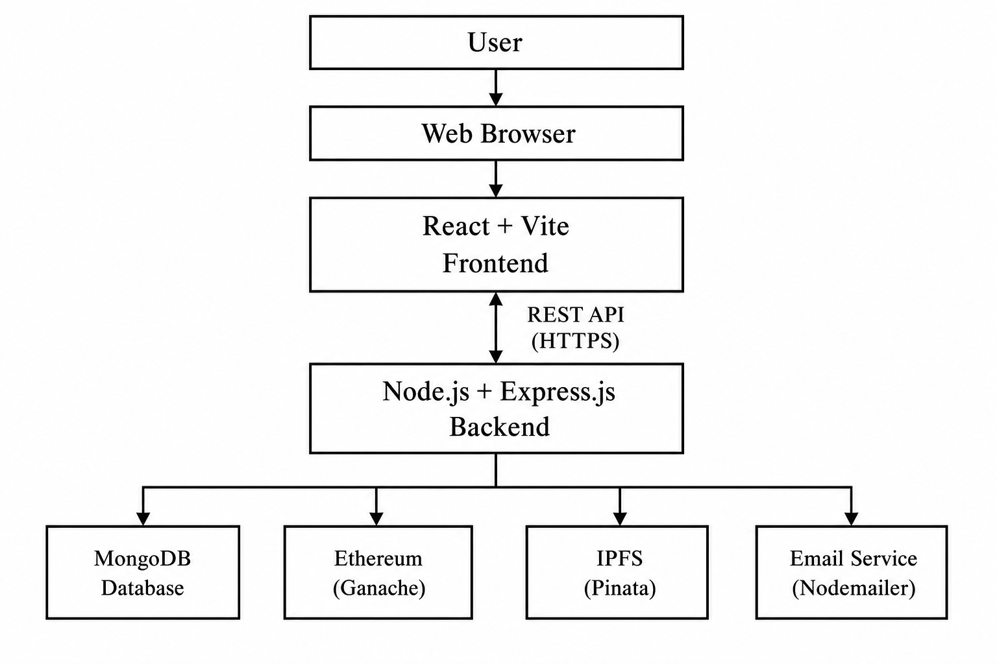
Figure 3.1: System Architecture of CertifyED

3.3 System Modeling
System modeling provides a visual representation of the structure, behavior, and data flow of the CertifyED platform. It helps describe how users interact with the system, how information moves between different components, and how data is organized within the application. The following diagrams were prepared to illustrate various aspects of the proposed system.
Flowchart:
The flowchart illustrates the overall workflow of the CertifyED platform, beginning with user authentication and continuing through certificate generation, blockchain storage, email delivery, and certificate verification.
This flowchart represents the sequence of operations and decision points involved in major system processes, allowing developers and stakeholders to understand the logical flow of the application before implementation.
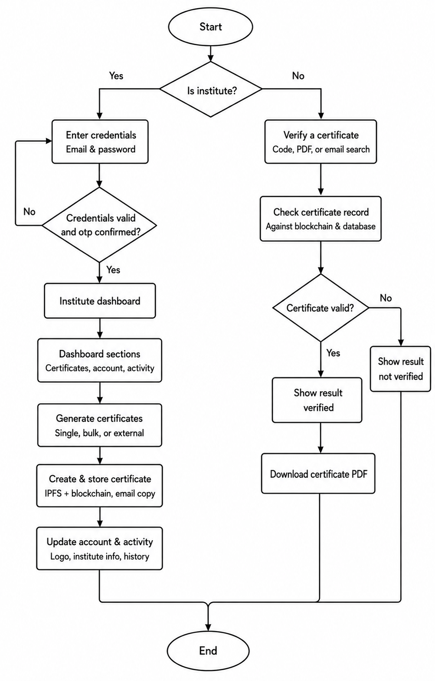
Figure 3.2: Flowchart
Use Case Diagram:
The use case diagram identifies the interactions between the system and its external actors. This diagram provides a high-level view of the services offered by the system.
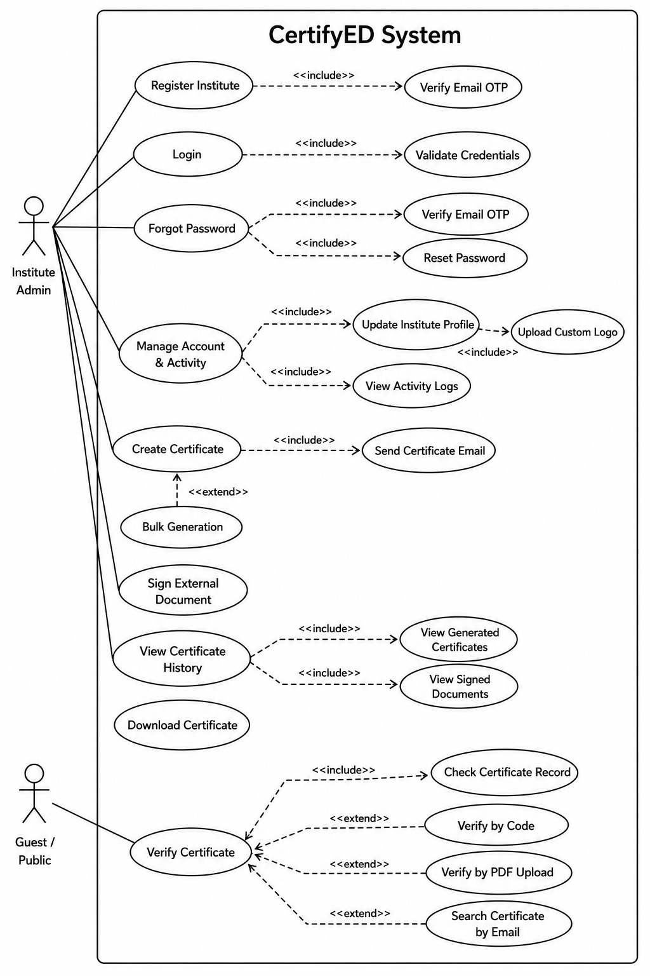
Figure 3.3: Use Case Diagram
Level-0 Data Flow Diagram:
The Level-0 DFD presents the overall data flow between external entities and the CertifyED system. It demonstrates how institutions submit certificate information, how the system processes requests, stores records, communicates with blockchain and IPFS services, and returns verification results to users. This diagram provides a high-level overview of the system's major processes.
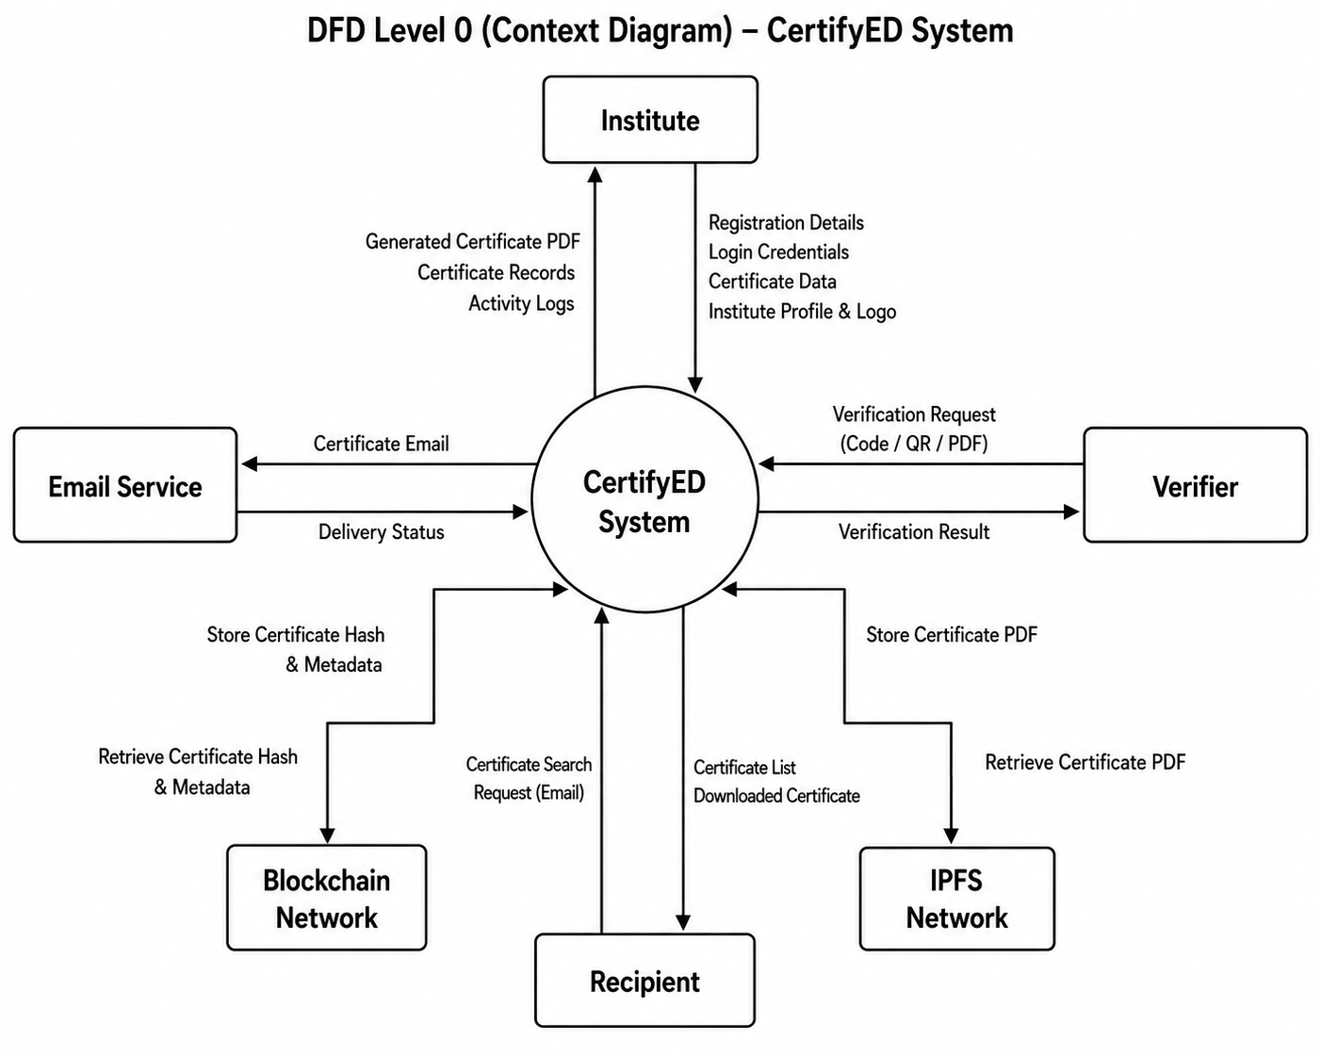
Figure 3.4: Level-0 DFD

Level-1 Data Flow Diagram:
The Level-1 DFD expands the major processes shown in the Level-0 DFD by illustrating the internal data flow among different modules. This detailed representation helps explain how data is processed throughout the system.
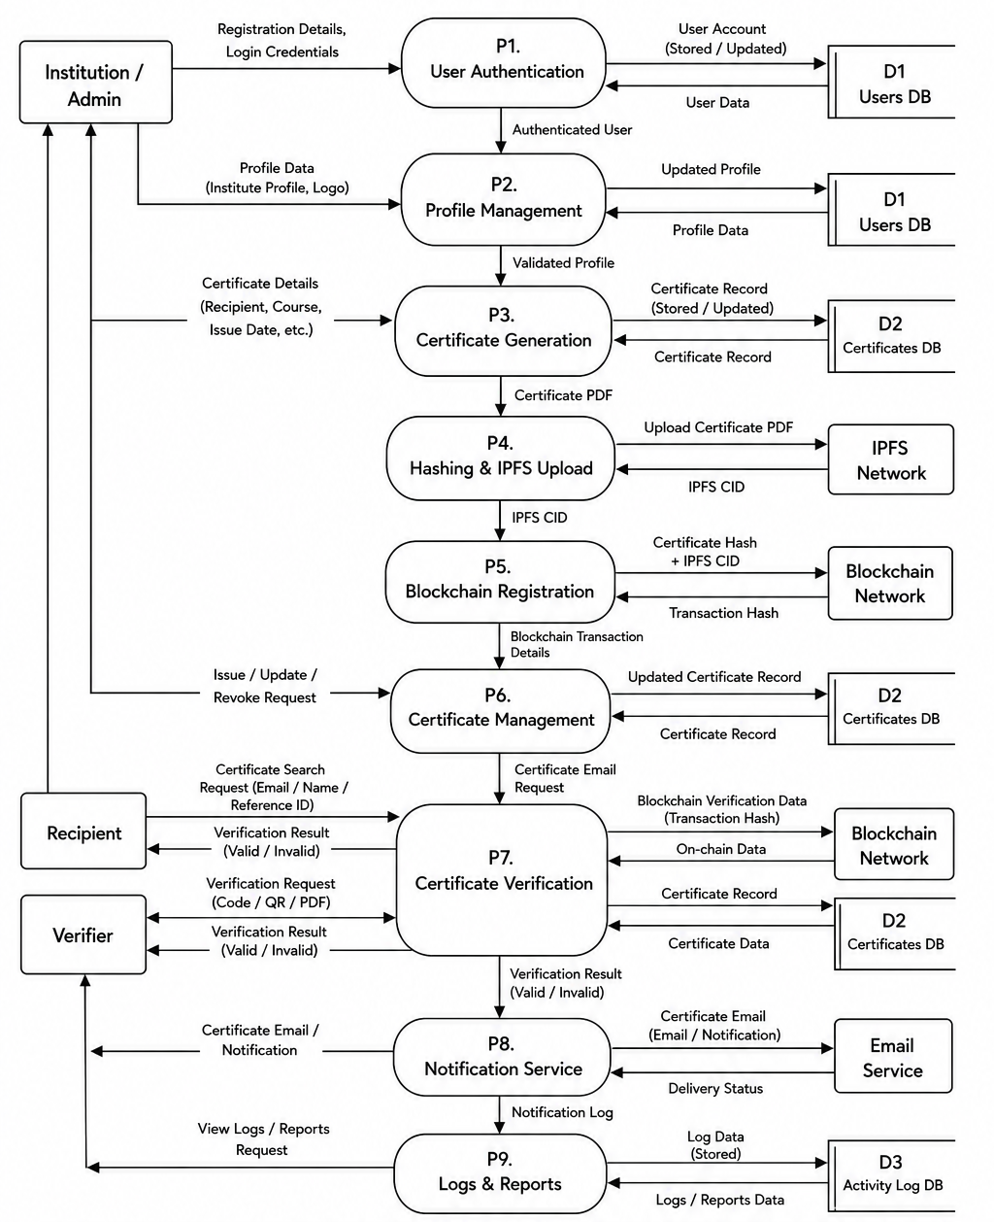
Figure 3.5: Level-1 DFD

Activity Diagram:
The activity diagram models the workflow of users performing operations within the CertifyED platform. It represents the sequence of activities involved in processes such as login, certificate generation, verification, and document signing.
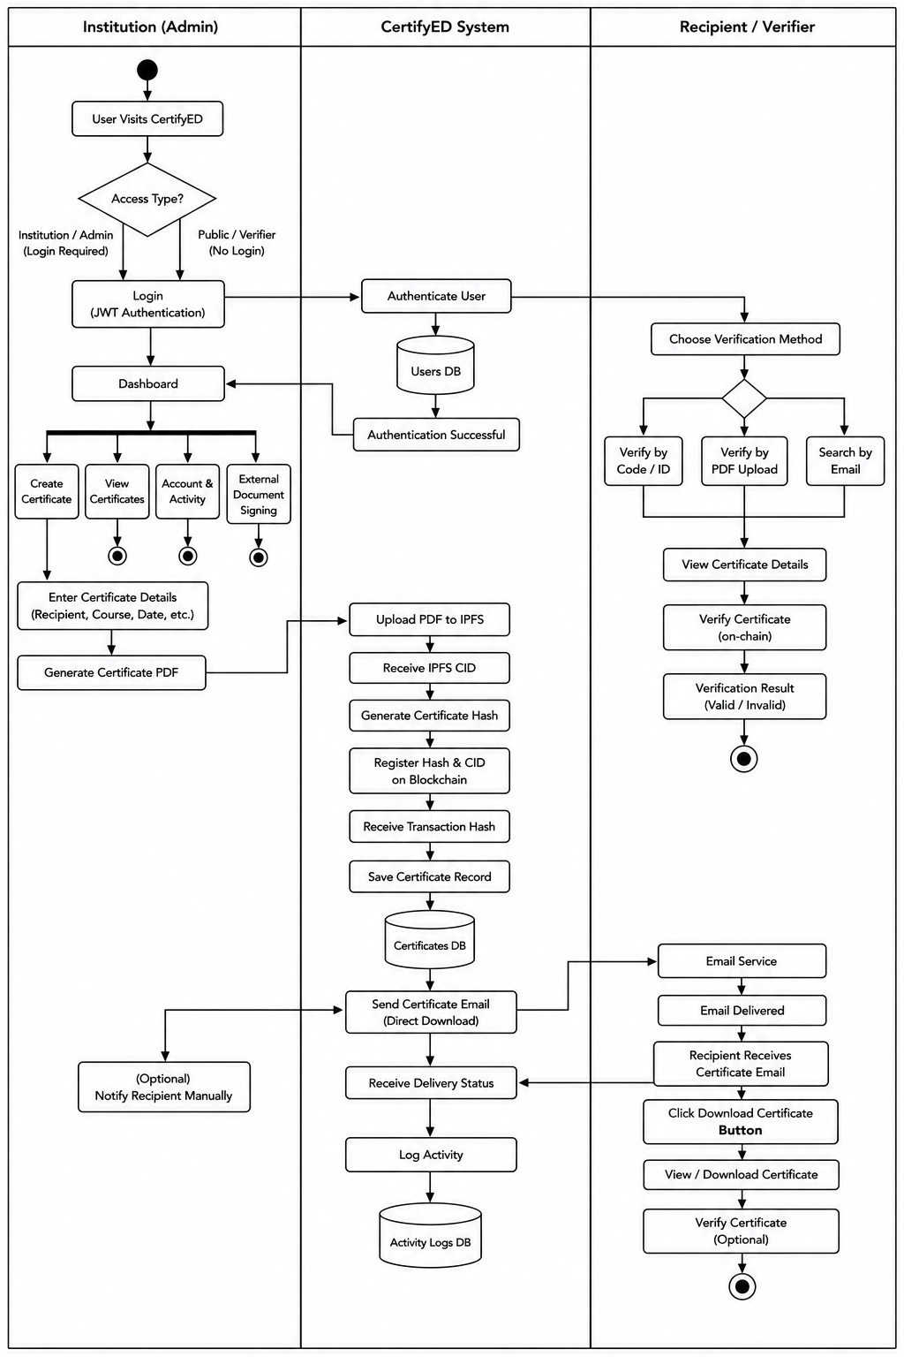
Figure 3.6: Activity Diagram
Entity Relationship Diagram:
The ER diagram describes the database structure of the CertifyED platform by showing the entities, their attributes, and the relationships between them. It illustrates how certificate records, user accounts, and activity logs are connected, serving as the blueprint for the MongoDB database design.
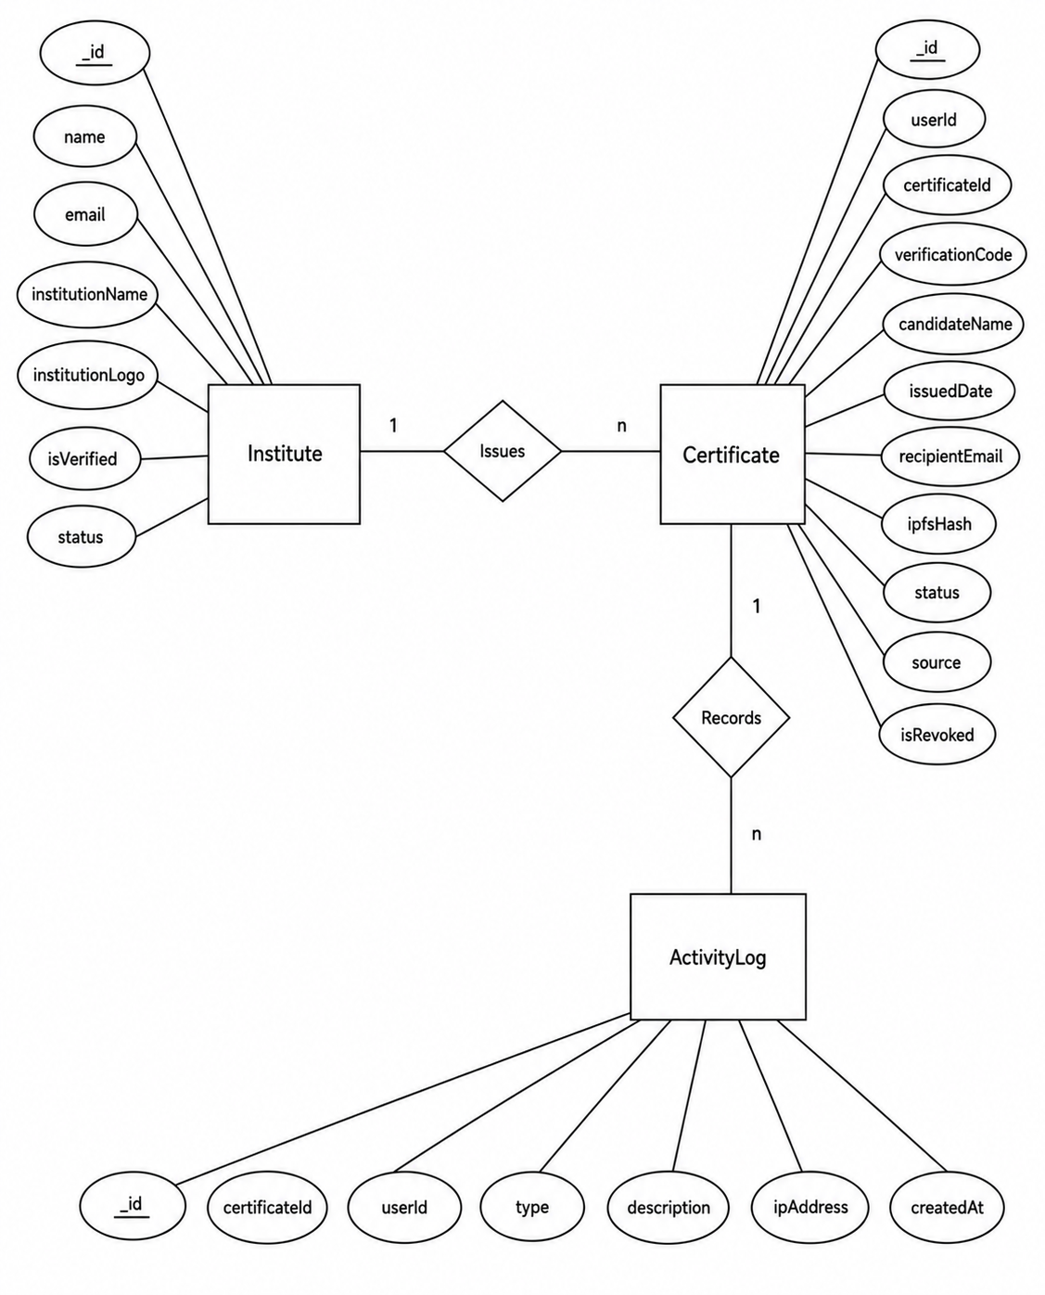
Figure 3.7: ER Diagram
Class Diagram:
The class diagram illustrates the static structure of the CertifyED system by representing its classes, attributes, methods, and relationships. This diagram serves as the blueprint for the object-oriented implementation of the system.
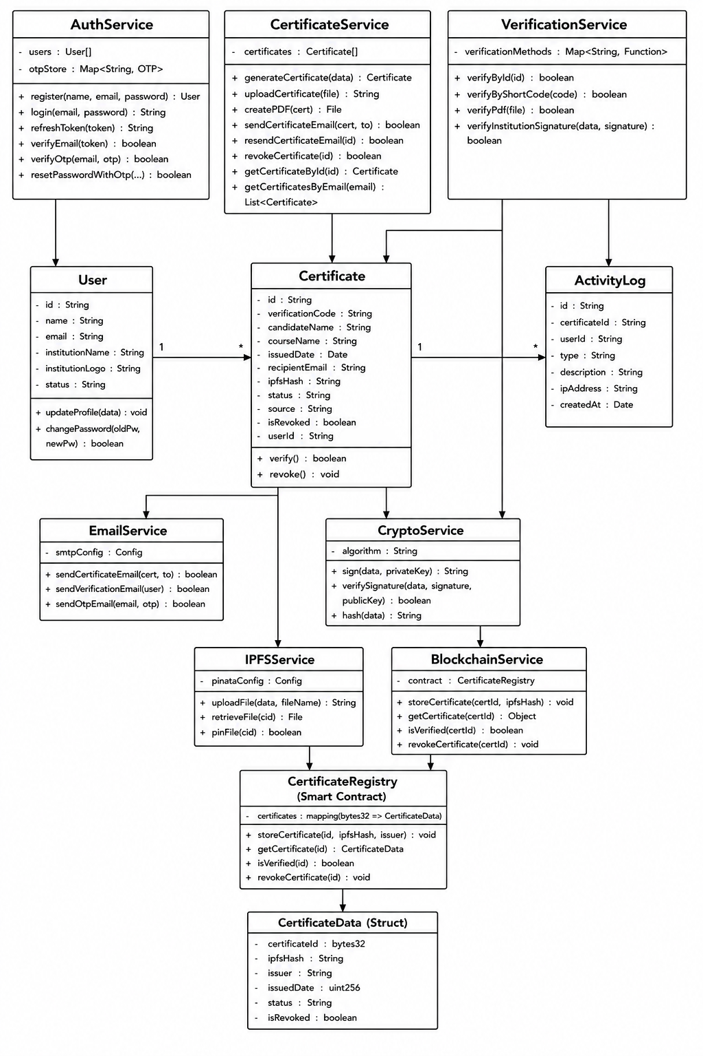
Figure 3.8: Class Diagram

3.4 Coding
The CertifyED platform was implemented using a client-server architecture with React (Vite) for the frontend and Node.js with Express.js for the backend, while MongoDB managed users, institutions, certificates, and activity logs. Ethereum blockchain (via Web3.js and Ganache) ensured certificate integrity, and IPFS through Pinata provided decentralized certificate storage. Git and GitHub were used for version control throughout the development process.
Programming Language:
- JavaScript and JSX were used for frontend and backend development.
Frontend Technologies:
- React with Vite for developing the user interface.
- Tailwind CSS for responsive and utility-based styling.
- React Router DOM for client-side routing.
- Axios for communication between the frontend and backend.
- React-PDF for rendering PDF documents.
- Konva and React-Konva for dynamic certificate template generation.
- XLSX for processing Excel files during bulk certificate generation.
Backend Technologies:
- Node.js as the server-side runtime environment.
- Express.js for developing RESTful APIs.
- Multer for handling file uploads.
- PDFKit for generating certificate PDFs.
- Nodemailer for sending certificates through email.
- Handlebars for creating dynamic email templates.
- Morgan for logging HTTP requests.
- Socket.IO for real-time communication where required.

Database:
- MongoDB for storing users, institutions, certificates, verification records, and activity logs.
- Mongoose as the Object Data Modeling (ODM) library for interacting with MongoDB.
Authentication and Security:
- JSON Web Token (JWT) for user authentication and authorization (Jones et al., 2015).
- bcrypt for securely hashing user passwords.
Blockchain and Cryptography:
- Solidity for developing Ethereum smart contracts.
- Web3.js for interacting with the blockchain.
- Ganache as the local Ethereum blockchain for development and testing.
- Pinata (IPFS) for decentralized storage of certificate files.
- Node.js Crypto module for generating cryptographic hashes used during certificate verification.
Other Tools:
- Docker Desktop for running Ganache and related development services.
- Git and GitHub for version control and project collaboration.

3.5 Testing
The project was tested using several testing strategies.
- Black Box Testing:
The platform was tested by end users without knowledge of the internal implementation. The UI was found to be intuitive and the core workflows functioned as expected.
- White Box Testing:
The codebase was reviewed by the developers, with unit tests covering individual API routes, certificate generation logic, and verification functions.
Table 3.2: Test Cases and Results
Test Case ID | Test Case | Expected Result | Outcome
1 | User Registration | User account created successfully for valid input | Passed
2 | Login | User authenticated successfully with only valid credentials | Passed
3 | Password Reset | Password reset email sent after receiving the valid code sent to the user and changed password | Passed
4 | Generate Certificate | Certificate generated successfully from user input | Passed
5 | Bulk Generation | Multiple certificates generated from uploaded file in the right format | Passed
6 | Email Delivery | Certificate delivered to recipient for existing email and failed if the email does not exist | Passed
7 | Verify by Code | Certificate verified for valid signed code | Passed
8 | Verify by PDF | Uploaded PDF verified for signed document | Passed
9 | Search by Email | Certificates displayed when they exist for input email | Passed
10 | Sign External PDF | Document signed successfully in pdf formats | Passed
11 | Verify External PDF | Signed PDF document verified successfully | Passed
12 | Activity Log | Activity recorded correctly | Passed

Chapter 4: Project Schedule
The project schedule was prepared to ensure the systematic completion of the CertifyED platform within the allocated timeframe. The development process was divided into multiple phases, including project pre-planning, system design, development, integration and testing, and documentation. Each phase was scheduled according to the project objectives and monitored throughout the development process to ensure timely completion. The overall project was successfully completed according to the planned schedule.
Table 4.1: Project Schedule
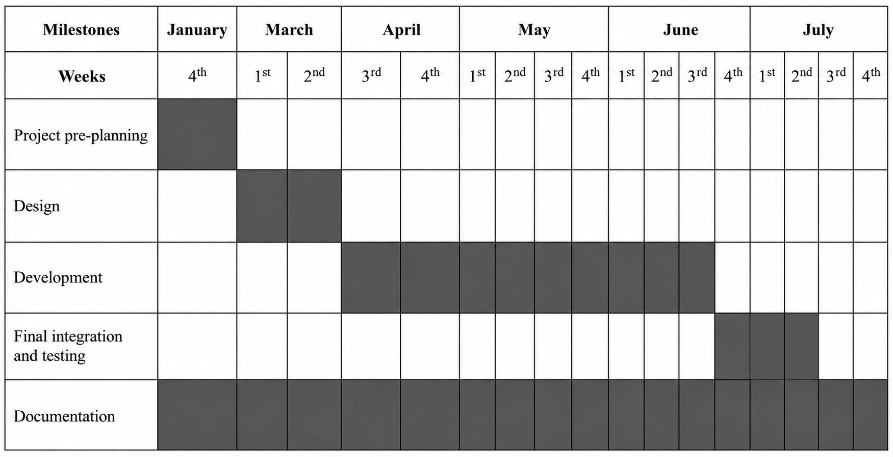

Chapter 5: Conclusion
The CertifyED platform was successfully designed, developed, and implemented as a blockchain-backed digital certificate management and verification system for educational institutions. The project achieved its primary objectives by providing a secure and efficient platform for certificate generation, management, and verification while addressing the limitations of traditional paper-based certificate systems.
The completed system supports user registration and authentication, single and bulk certificate generation, automated email delivery, public certificate verification using verification codes, PDF uploads and recipient email, external document signing and verification, institution profile management, activity logging, and certificate record management. The integration of Ethereum blockchain ensures certificate integrity through immutable hash storage, while IPFS provides decentralized storage for certificate files, improving reliability and resistance to tampering.
Throughout the development process, modern web technologies including React, Node.js, Express.js, MongoDB, Ganache, IPFS, and GitHub were successfully integrated to develop a scalable and user-friendly application. The modular architecture enables future enhancements while maintaining system performance and maintainability.
Overall, CertifyED demonstrates that blockchain technology can significantly improve the security, authenticity, and efficiency of digital certificate management. The platform provides educational institutions with a reliable solution for issuing, managing, and verifying academic credentials while reducing administrative workload and minimizing the risk of certificate forgery. The successful completion of this project establishes a strong foundation for future improvements, including deployment on a public blockchain, enhanced analytics, integration with institutional information systems, and support for mobile applications.

References
Buterin, V. (2014). A next-generation smart contract and decentralized application platform. https://ethereum.org/en/whitepaper/
Certifier. (2025). Ranking the best digital credential service providers. https://certifier.io/blog/digital-credential-service
CertifyMe. (2025). Verifiable digital credential platform. https://www.certifyme.cc/
Certopus. (2022). About Certopus. https://blog.certopus.com/about
Ethereum Foundation. (n.d.). Ethereum documentation. https://ethereum.org/en/developers/docs/
Fielding, R. T. (2000). Architectural styles and the design of network-based software architectures. University of California, Irvine.
Jones, M., Bradley, J., & Sakimura, N. (2015). JSON Web Token (JWT). RFC 7519. https://datatracker.ietf.org/doc/html/rfc7519
MongoDB Inc. (n.d.). MongoDB documentation. https://www.mongodb.com/docs/
Nakamoto, S. (2008). Bitcoin: A peer-to-peer electronic cash system. https://bitcoin.org/bitcoin.pdf
Oracle. (n.d.). What is client-server architecture? https://www.oracle.com/database/what-is-client-server-architecture/
Protocol Labs. (n.d.). IPFS documentation. https://docs.ipfs.tech/
React. (n.d.). React documentation. https://react.dev/
Royce, W. W. (1970). Managing the development of large software systems. Proceedings of IEEE WESCON.
Sertifier. (2025). Digital credential platform. https://sertifier.com/

Annexes
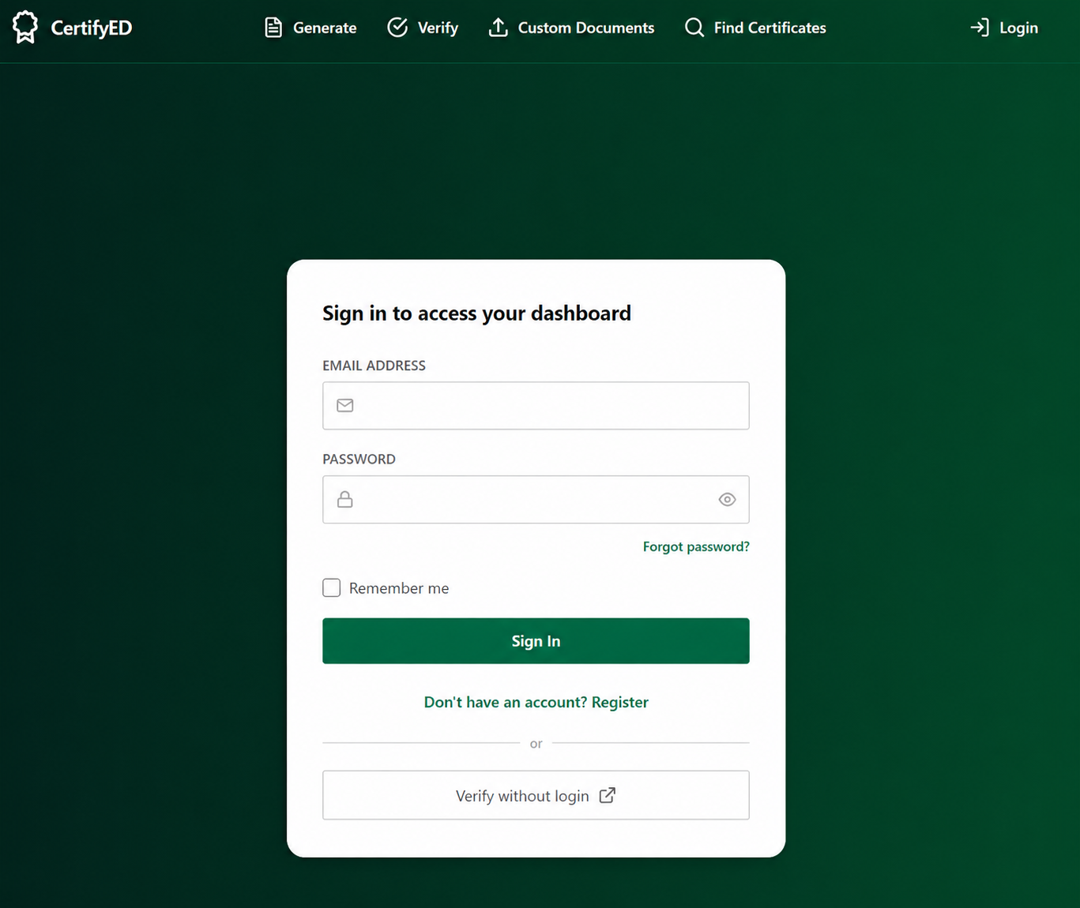

Annex I: Login Page
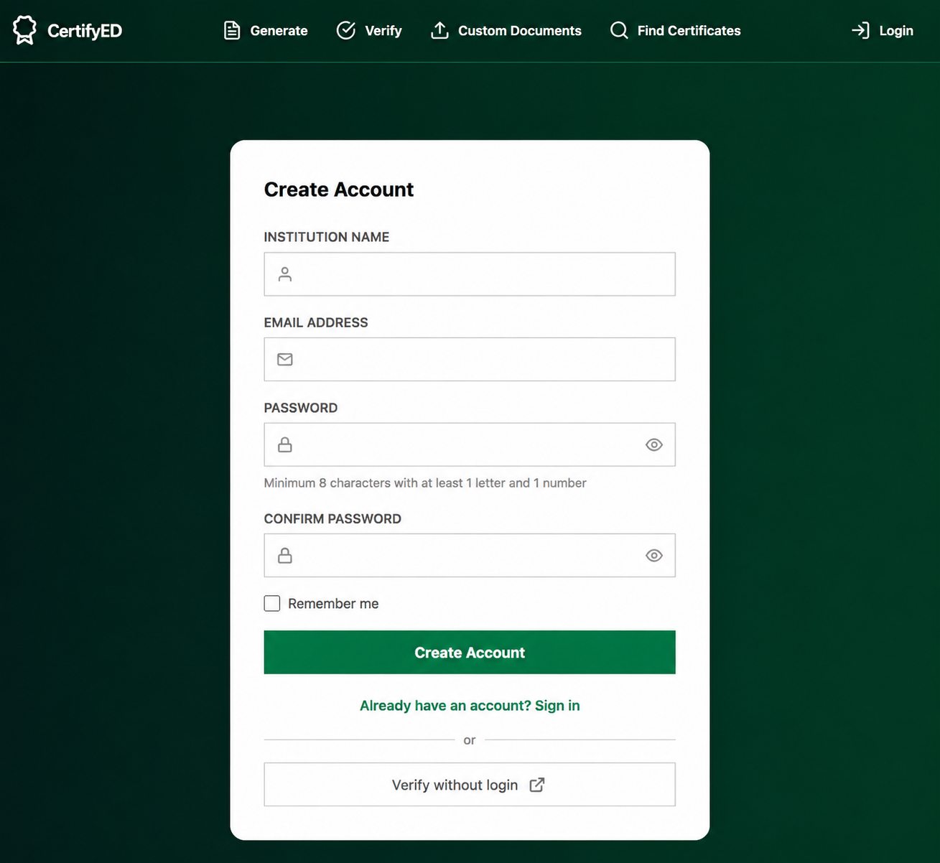

Annex II: Register Page
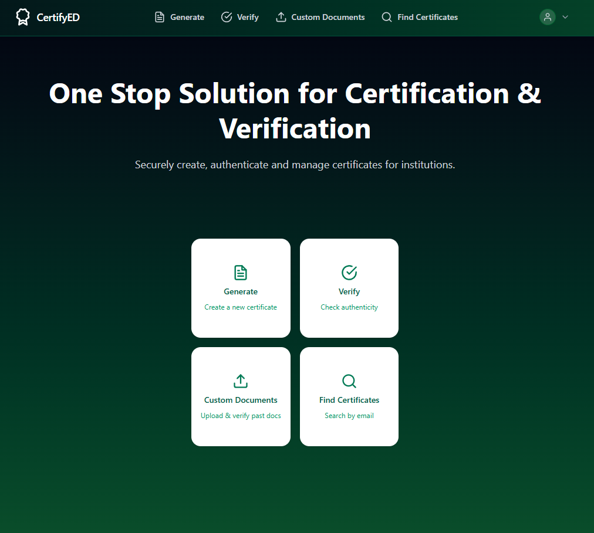

Annex III: Home Page
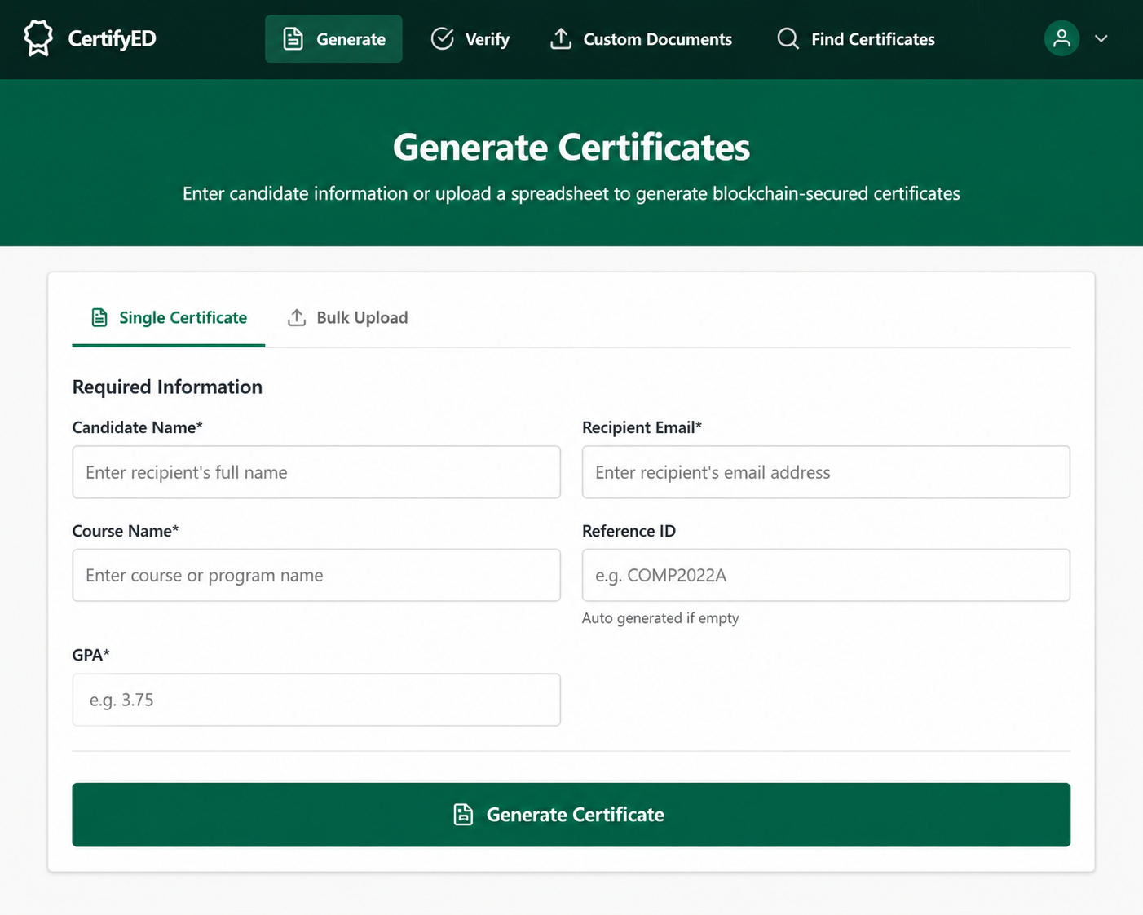

Annex IV: Certificate Generation Page
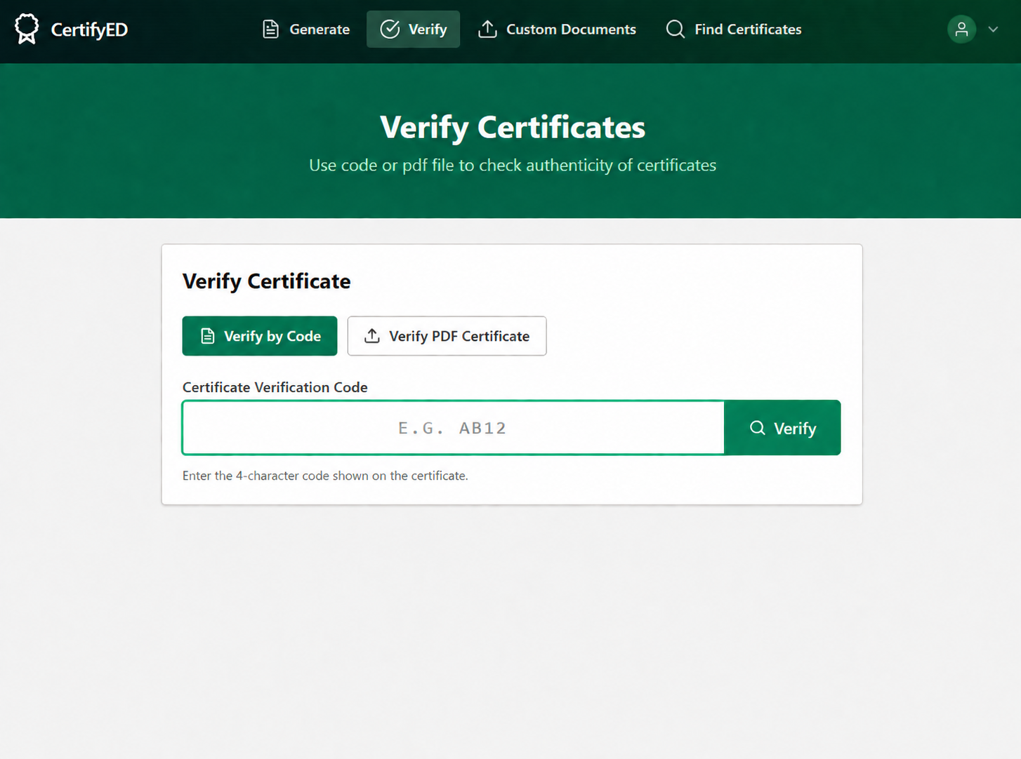

Annex V: Certificate Verification Page
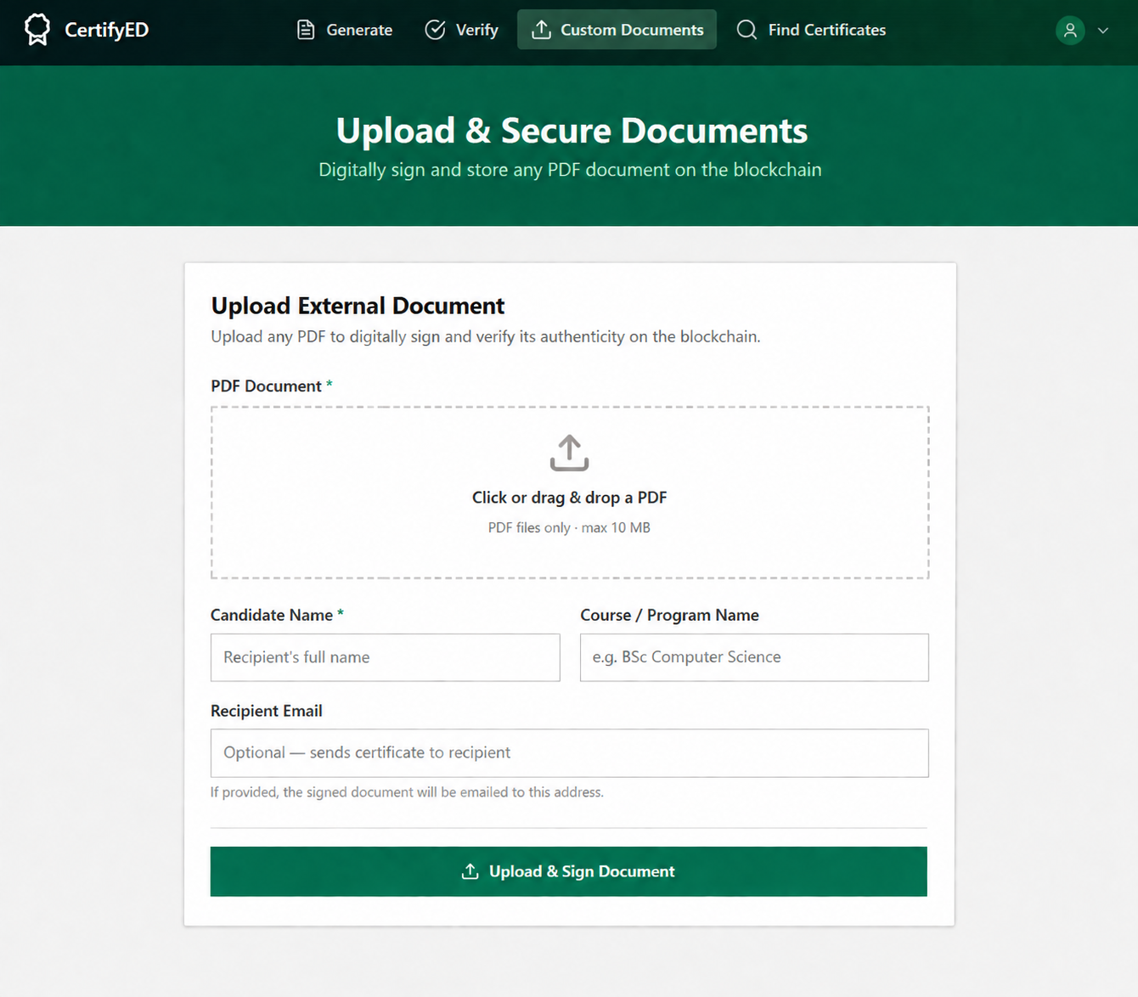

Annex VI: Custom Document Upload Page

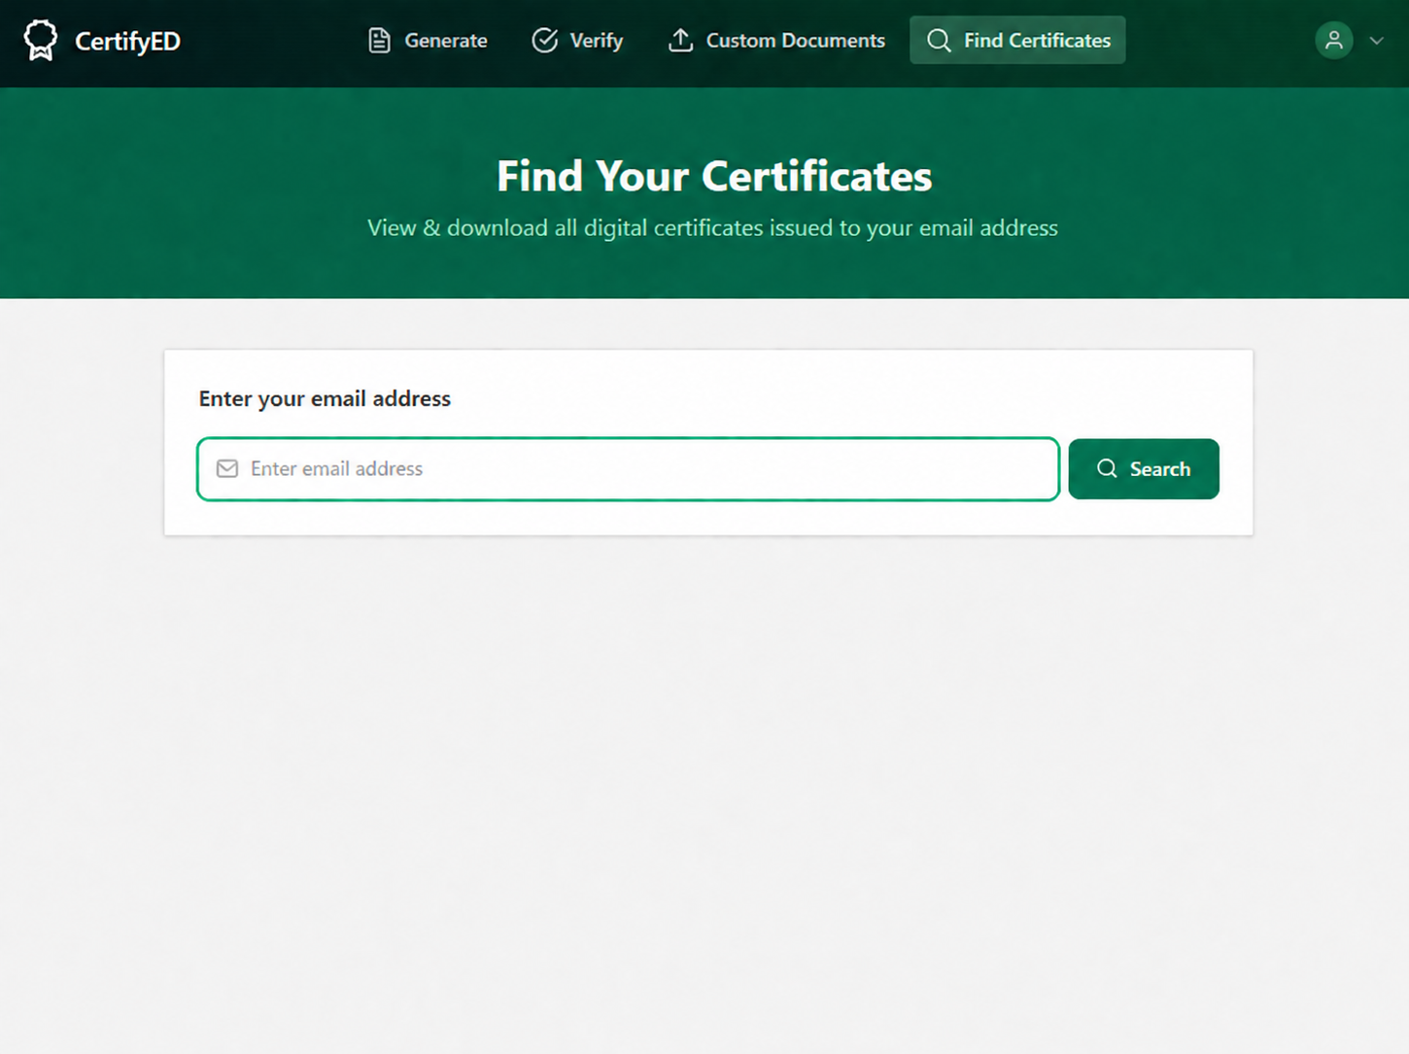

Annex VII: Find Certificate by Email Page

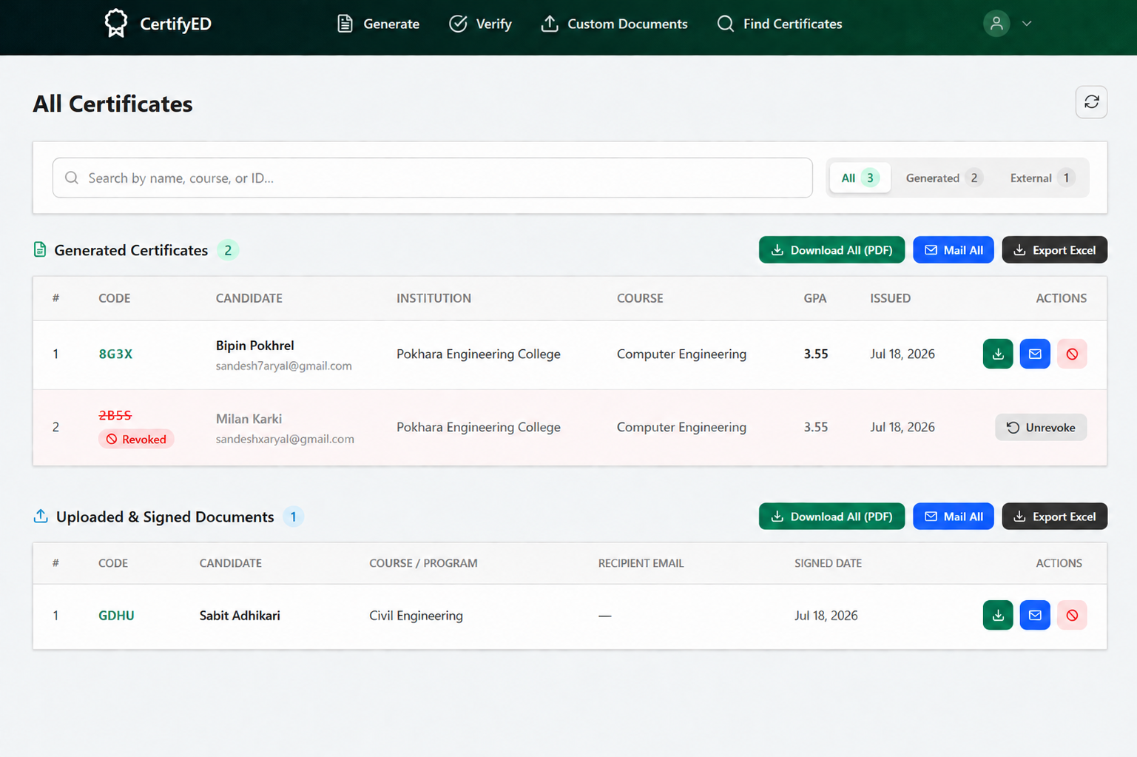

Annex VIII: All Certificates Page

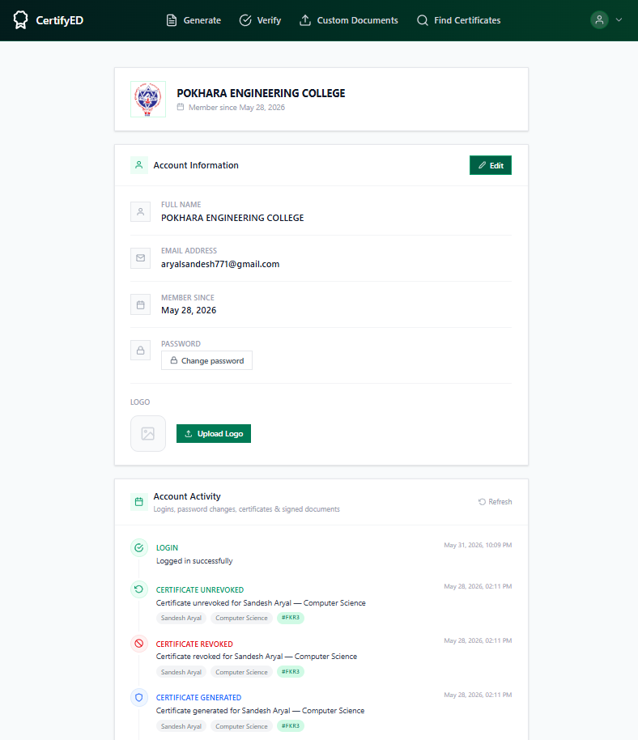

Annex IX: Account and Activity Page

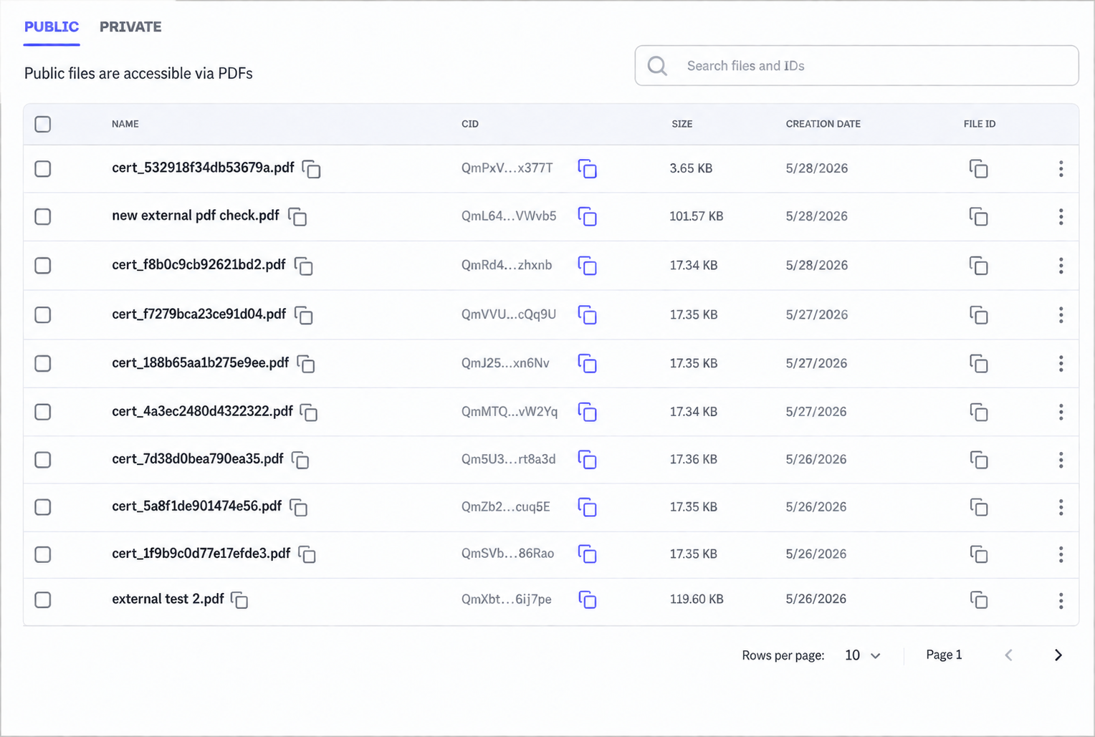

Annex X: Pinata IPFS Dashboard
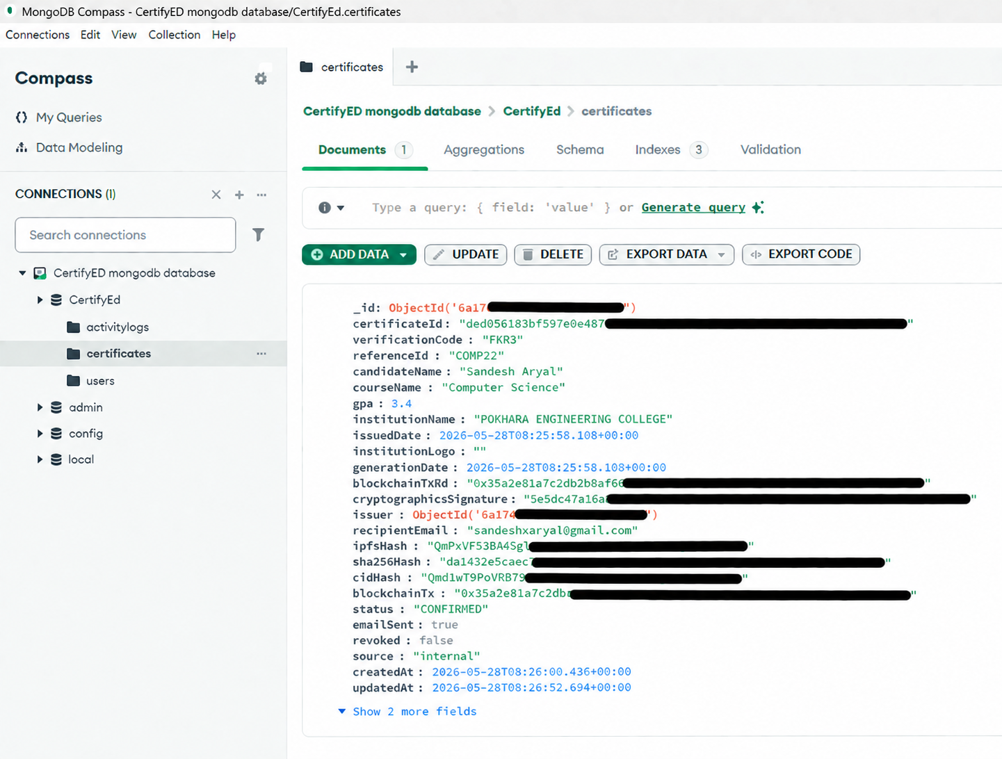

Annex XI: MongoDB Compass Dashboard

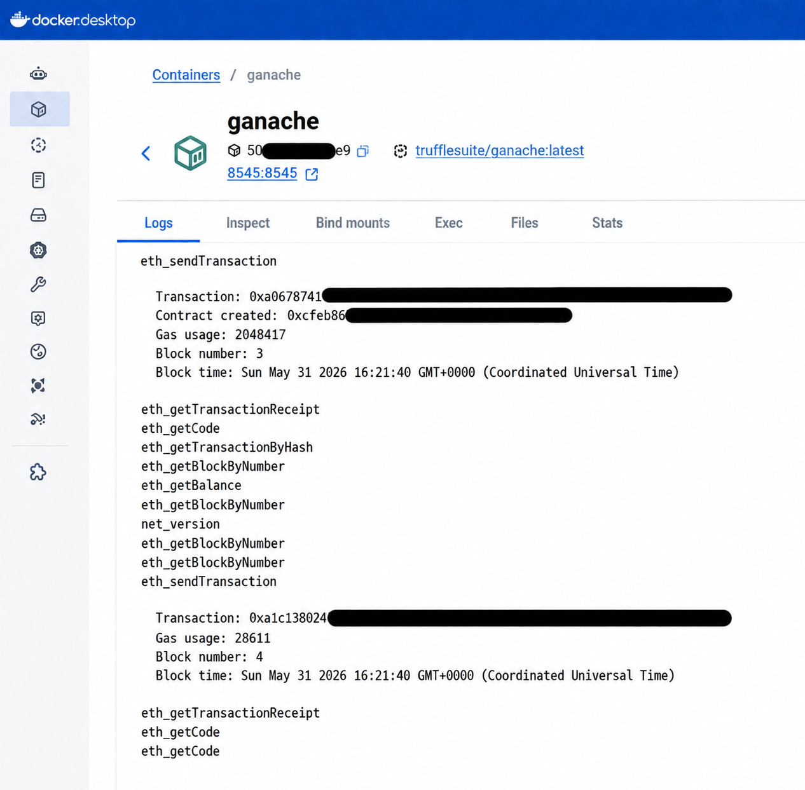

Annex XII: Docker Desktop Ganache Dashboard

Date: July 24, 2026
CERTIFICATE
The project entitled "CertifyED" proposed by the students Bipin Pokhrel (22070448), Milan Karki (22070453), and Sandesh Aryal (22070462) of Pokhara Engineering College, under the Department of Computer Engineering, has been submitted on the standard format proposed by RMC. This project report has been found feasible and is not submitted elsewhere for the award of any other degree and thus accepted.

……………………………..
Er. Sabin Thapa
Project Supervisor

……………………………..
Er. Krishna Ghimire
Co-ordinator, Research Management Cell

……………………………..
Er. Suraj Basant Tulachan
Head of the Department, Computer Engineering

……………………………..
Dr. Bidur Devkota
External Examiner

